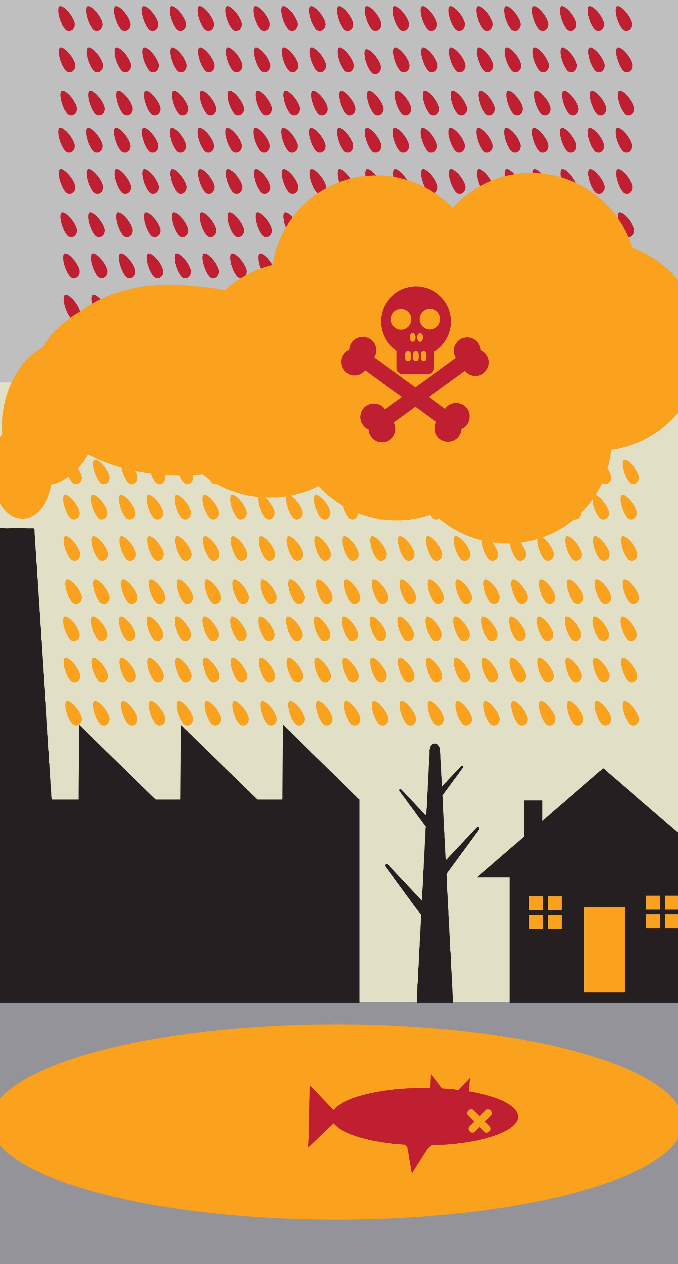
June 9, 2016

Citizens Against the Rehoboth Compressor Station
Type to enter text

Mr. Skip Vadnais
Chairman
Rehoboth Board of Selectmen
148 Peck St.
Rehoboth, MA 02769

Dear Mr. Vadnais,
We appreciate your time and dedication in the effort to protect Rehoboth with regards to Spectra and relative to the Compressor Station. We value the opportunity to present your Board with our questions, concerns, and requests regarding this topic. We understand you are representing the entire town thus taking into consideration both sides. So we will set aside our request that you to take a stand against our very real concerns regarding the pollution (neurotoxins, noise, lights, etc.) and the inherent dangers of this project until you can collect more information. Instead we will focus on the unfair tax being foisted upon us. We strongly feel that Rehoboth as a whole would agree that this enforced tax to pay for a private corporation, in an unregulated and volatile industry, with the purpose of building its infrastructure in a for-profit venture with no guarantees is an outrageous misuse of taxation. Further, with the renewed call to ban fracking around the world we will be obligated to pay this tariff whether we end up using gas or not. Why are we saddled with this risk?
We are asking the Board of Selectmen as a unified body and in its official capacity to write to Governor Baker and publicly oppose this tax as a way of funding the Algonquin expansion. We feel it is unconscionable and we are not alone, the AG. Maura Healy has also expressed great concern with this very issue of the DPUs “pipeline tax.” The Conservation Law Foundation with GSF Suez is currently taking this matter through the Supreme Court system of MA. So far Spectra energy has not yet demonstrated a REAL need for this pipeline expansion. There are no contracts sold with the electric utilities to support this project. There are only two dockets filed with the DPU that are really just agreement applications with Eversource and Natl. Grid that represent a 20 year commitment to buy gas through a tax! And with that funding, the emerging structure of a utility preparing to export natural gas.
Your letter is VERY important to our community, and you will be joining with other towns throughout this state together in public opposition asking Spectra how they are demonstrating their need to FERC without selling any REAL utility contracts. Asking them, why should our electric ratepayers bear the financial risk of an energy company’s private investments? In fact, if Access Northeast claims to be for the benefit of our electric grid, why does the New England Power Generators Assoc. oppose the gas pipeline tax?
Please see page 7, http://nepga.org/2015/05/nepga-testimony-on-massachusetts-state-of-energy-hearing/
We strongly urge you to join with the towns of Acushnet, Sharon, and Freetown by inviting the Seekonk Board of Selectmen and the Mayor of Attleboro to join together with yourselves and draft letters to Governor Baker, Senator Downing, State Senator Ross, US Congressman Kennedy, US Senator Warren, US Senator Markey, and Sen. Timilty vehemently opposing this unfair and perhaps illegal tax. We are asking you to request the language of a BAN on any potential for a tax, surcharge, and tariff on our energy bills in any legislation put forth starting with the H.4377 Omnibus.
We might be a small group at this time, but you experienced over 100 interested residents attending the meeting at DR. We are a little farm town up against a multi-billion dollar corporation with lots of lawyers presenting a questionable and risky project. We will need to, and we are starting to, join together town-to-town across this state. Please, as legislators join our efforts; if you will not oppose this project outright then please oppose the unfair tax we will be burdened with.
Attached is the list of questions and concerns from this group to be put forth in a meeting with Spectra. We respectfully ask that our representative be present AND a representative selected by the Toxics Action committee to balance the conversation.
Sincerely yours,

Alys Vincent
Representative for the Citizens Against the Rehoboth Compressor Station group
cc Claire B. W. Miller, Toxic Action
Citizens Against the Rehoboth Compressor Station

Questions and requested actions for you to communicate to our Legislators:

- If N.E. is already dependent on gas (40% of our electricity) –a fossil fuel that research shows is more detrimental to our environment than coal because of the CO2 of methane (not to mention the tens of thousands of leaks adding to that), WHY are we adding more infrastructure tethering us to it for CENTURIES rather than weaning off fossil fuels and turning to renewables?
- Because this compressor station is located in a densely populated neighborhood, Spectra must be required to produce and pay for an independent third party environmental and health impact study in the area of homes, schools, churches, and public recreation spaces that abut the compressor site by at least 1 mile outside the proposed compressor station property boundaries.
- Join with AG. Maura Healy and many other affected communities to draft a letter to the FERC requesting an extension of the public comments period regarding the Access Northeast project until AFTER the release of Spectra’s “full set of resource reports.” Also please request additional FERC meetings IN Rehoboth for our community to comment because the previous meetings were almost an hour away and timed during rush hour traffic making it very difficult to attend them. And finally, please demand that ALL of the abutters MUST be notified of any hearings when there is an opportunity for comments or concerns as many homeowners are UNAWARE of what is happening.
- Pass a resolution to call on our legislators to PROHIBIT a pipeline tax and commit to vote against any disposition legislation that would remove permanent protections from public lands for any pipeline project.
- If Governor Baker still insists on a Pipeline tax, call for legislation requiring the opportunity for constituents to vote on it.
- The Access Northeast project severely impacts our wetlands. We ask you to urge Governor Baker to deny a 401-water quality permit.
- Join Senator Warren by supporting her bill in creating an office of public participation and consumer advocacy within the Federal Energy Regulatory Commission.
- Require Algonquin to present an inventory of present pipeline leaks and demand them to repair or replace the existing outdated, leaking and compromised pipes.
Questions for Spectra:
- Who are the customers for all the expected pipeline capacity? How will Spectra demonstrate a REAL need with the only contracts being two dockets filed with MA Dept. of Public Utilities 15-181 and 16-05 representing a commitment by Eversource and Natl. Grid to buy this gas through a 20-year tax paid for by electric ratepayers? The only customers they have are their own partners in the Access Northeast project! Essentially they are just buying and selling amongst themselves and passing the cost of construction to us. If there actually was a need wouldn’t the power companies be buying contracts for this Gas?
- Why should electric ratepayers pay a tax to support the Access Northeast? As a private corporation working in a deregulated market, shouldn’t you bear the financial risk?
- Since ratepayers are being asked to pay for the new pipeline infrastructure, pay for the gas that comes out of it, and upon completion turn over full ownership rights of the pipeline and contents to Algonquin, what is the benefit of our investment?
- Since the Attorney General is the ratepayer advocate, and that offices study determined that more gas infrastructure is not needed to keep the lights on, why is Spectra pursuing a project to add more gas for electricity in our region?
- Is there any plan to export any of the gas that will be transported by the expanded pipeline? We are aware that the Spectra Atlantic Bridge project reverses the flow of gas on the Maritimes and Northeast pipeline to allow gas to flow from the United States to Canada. If export occurs, will there be any guarantees that we, who would be burdened by the new gas infrastructure, be immune from price increases due to higher prices elsewhere?
- After the compressor goes online, what will be the resulting pressure and capacity in the existing pipelines? What are they rated for?
- How is Algonquin testing integrity of the existing pipes, which are 40 to 60 years old? What steps are they taking to fix the existing leaks?
- How will the new pressure in the pipes affect those leaks?
- These pipes travel through many communities, how can we be sure our safety is not compromised? What is their protocol to test the pipes? How often do they test them?
- In the event of an accident at the compressor station site or down the line, what is the protocol for response? How is the gas turned off? How far are the shut off valves? Are the shut off valves both manually and remotely controlled? How long does it take to burn out the gas left in the line?
- We have a volunteer fire dept. what is their expected response in the event of a fire or explosion? Who will pay for this service?
- The typical venting process or blow down can and often does last 2 hours, what is the protocol for venting the compressor when there is a low cloud canopy? Do you follow our air quality laws by placing restrictions on these events occurring during cloudy weather unless in emergencies? How can you assure us there will be no disregard of these laws?
- How are the homeowners near and around the compressor station compensated to their drop in property value? What is their recourse should their health and way of life become compromised?
- Will all the new lines and infrastructure be leak free? Are zero-leak facilities now a FERC requirement? If not, why?
- Is the compressor station subject to the EPAs new methane emission rules? https://www3.epa.gov/airquality/oilandgas/
- What is your plan for endangered species-plant or wildlife-that would be impacted by the proposed pipeline and associated infrastructure?
- What funds would be set aside to mitigate against any harm brought to property or persons through an accident or otherwise by the proposed project? What guarantees would there be to prevent the companies in question to declare bankruptcies and avoid damages?
- Algonquin is supposed to provide two alternative sites. For the compressor station. Where are they?
- Why are the compressor station turbines not electric, which are quieter, and less polluting?
- What kind of assurances will be given that once the one 10,310 hp compressor is installed Spectra wont come back again for an expansion of the site and install multiple compressors as it has done elsewhere?

